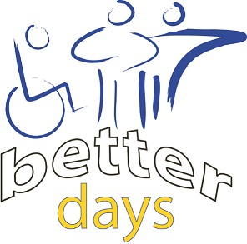
Are you an adult with a learning disability who has always wanted to ride a bike, but
needed someone to show you how to ride?
Did you ride a bike when you were young but have not been on one since?
Come to our Beginners Cycling Sessions
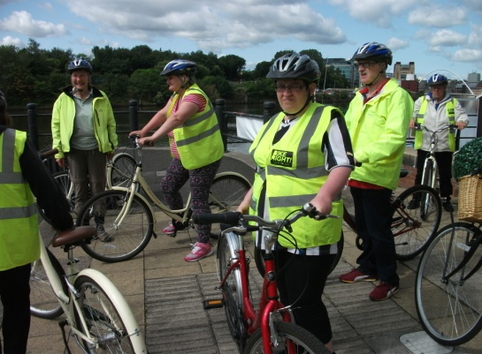

We meet every two weeks down at the Cycle Hub, Quayside, Newcastle upon Tyne NE6 1BU
You do not need your own bike or helmet as you will be able borrow these for the session and you will be given instruction on how to ride safely.
If you would like to take part please contact
Glenn Howe on: Tel: 0191 281 5541
E-mail: betterdays1999@hotmail.com

