9



**31**

**st**

**May 2018**

**New College**

**Durham**

**am**

**10**

**–**

**pm**

**1**

**For further information please contact Paul James on: 03000 265521. Alternatively email**

**Paul.Richard.James@durham.gov.uk or call one of the team on 03000 265443.**



**At the event there will**

**be fun activities, karaoke**

**free prize draw**



**With over 80 stalls! Social**

**Activities, Health, Support,**

**Advice and Carers zones**

**showing what is on offer for**

**you. A day packed full of**

**information for people with**

**physical, learning disabilities**

**disabilities and**

**and carers.**

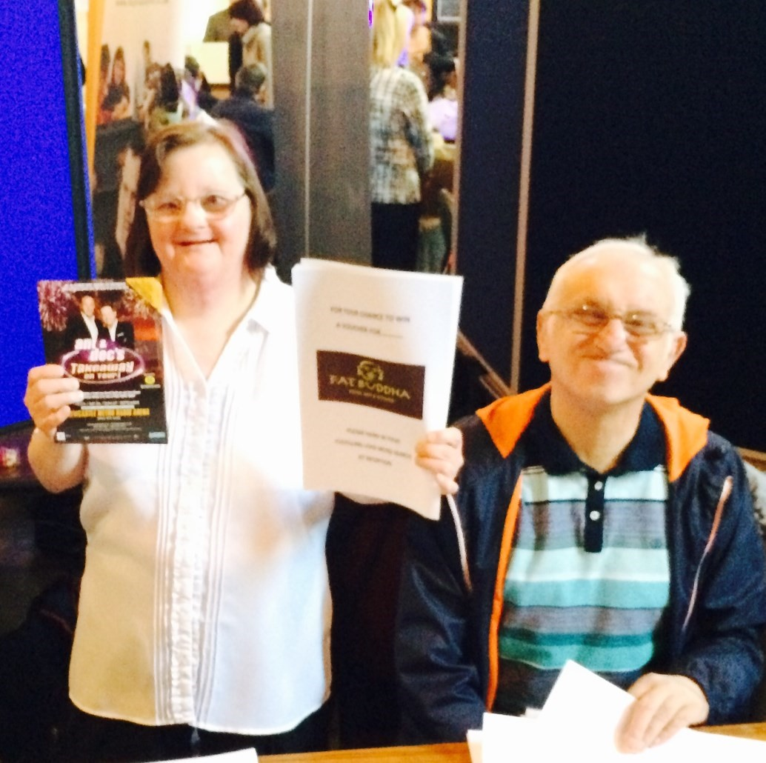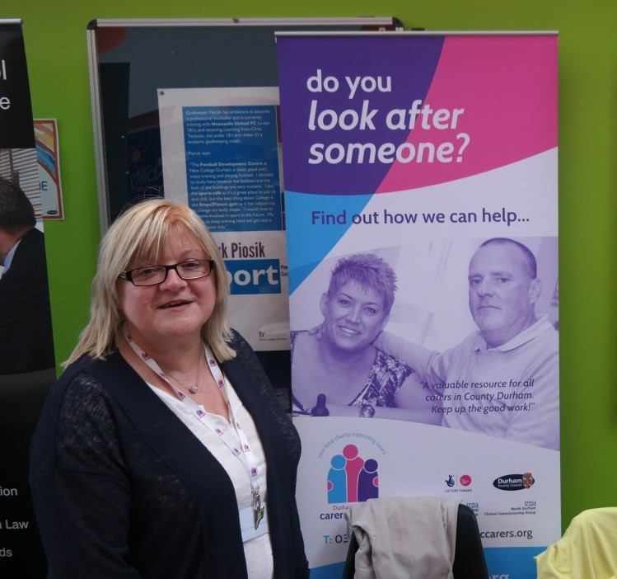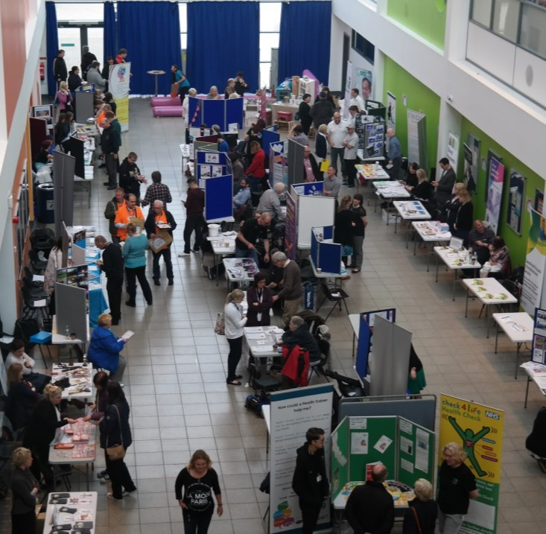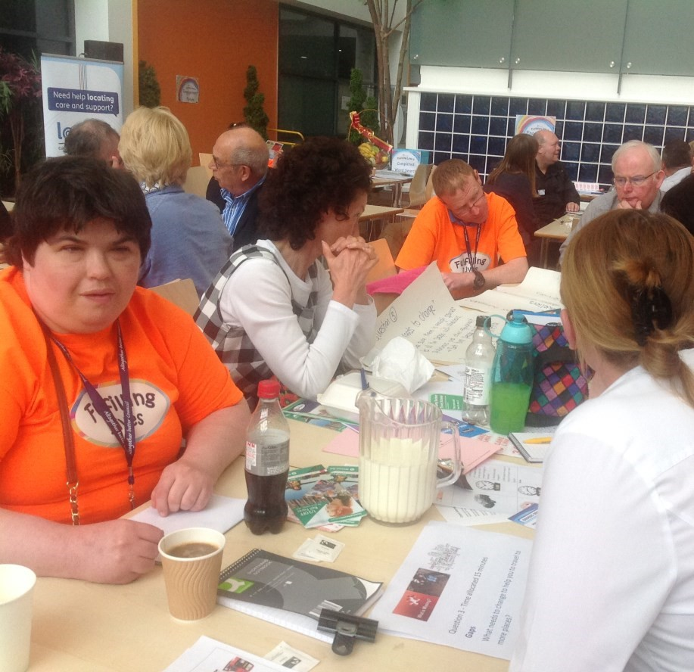

**9**