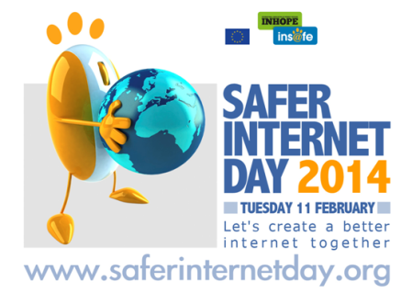Safer Internet Day – 11th February 2014
Safer Internet Day 2014 will take place on 11th February 2014, with the theme 'Let's create a better internet together', to promote the safe and responsible use of online technology and mobile phones for children and young people.

What Can YOU do?
As well as educational packs for staff, there is also a parent pack, providing great ideas to help schools and organisations to get involved.
- School packs – these include an assembly presentation , a quick activities sheet, drama activities, lesson plans and posters
- Parent pack – you will find useful resources and guidance to run a parent/carer session in your organisation, such as conversation starters, posters and information sheets

For the first time, a special programme, SIDtv, will be streamed live from the site throughout the day, with hourly slots dedicated specifically for parents/carers, students and professionals

Where can I find these resources?
Everything you need is available here: http://www.saferinternet.org.uk/safer-internet-day/2014/schools-packs

Top Tip from Greenford High School:

Why not show a really powerful video created by Digizen, called ‘Let’s Fight it Together’ (7 minutes): - http://old.digizen.org/cyberbullying/fullfilm.aspx ?
This can be used to kick start a discussion on the impact of cyberbullying. If you have time, you can follow this up with the 5 short videos available of character interviews with the target, bully, bystander, teacher and mum from the story (5 minutes in total) to provide a greater insight into the behaviours surrounding cyberbullying and ideas to tackle it.

