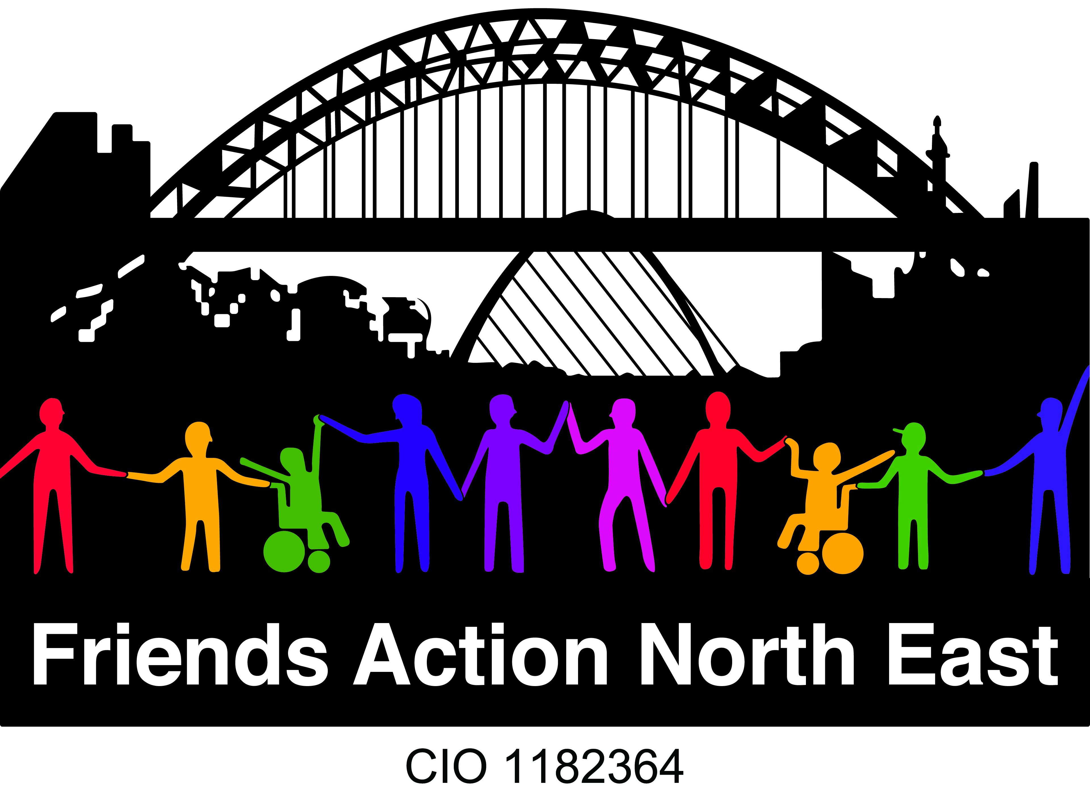

|  |  |  |
| --- | --- | --- |
| **Application/referral form for the one-to-one friendship mentoring project** | | |
| **Name:**  **Date:** |  | Are you a person with a learning disability diagnosis?  (Please circle)  **Yes No**  Do you have a diagnosis of autism?    **Yes No**  Please provide more details if you would like to  What kinds of things do the people who support you, help you to do? |
| **Address:** |
| **DOB:**  **Email Address:** | What are you interested in or what are your hobbies? |
| **Your own Phone Numbers:**  Land Line:  Your Mobile:  We need two numbers so that we have people we can contact if you have any difficulties or there is an emergency.  **Emergency Contact details**  1. Name:  Tel:    Email:  2. Name:  Tel:  Email: | **What support do you have in your life now?**  Agency  Family / other Carer  Other – please describe  **Do you have anything you find difficult that you need support with that you think we should know about?**  Please describe below: |
| **Which group or activity are you interested in?**    ZOOM Socials  Friendkit Training  Tech Smart workshops  Face to Face meet up |
| **Who has referred you?**  Name:  Organisation:  Email:  Tel:  **If you have self- referred, please provide 2 references (These would need to be provided by professionals such as GP, teacher, support agency)**  **Reference 1**  Name:  Organisation:  Email:  Tel:  **Reference 2**  Name:  Organisation:  Email:  Tel:  **What is the best way for us to contact you?**  Send me a letter Yes No  Speak to me on the telephone Yes No  Send me an email Yes No  (Please give us your email address)  **Anything else?**  Is there anything else you think we should know to make sure attending the group or activity goes well for you?  **How did you hear about us?**  **Have you ever been a victim of a Mate or Hate crime?**  So that we can support you to join our online activities we would like to find out about the equipment, internet access and support you have at home.  **Do you have internet at home?**  Yes No  **Do you use a smart phone?**  Yes No  **Do you have internet access on a device (phone/tablet/laptop)?**  Yes No  **Do you use social media?**        Facebook Twitter Snapchat Whatsapp Instagram Tik Tok    Other_________________________________________________________  **Do you know someone that can help you to join online groups and activities?**  **If they are happy for us to contact them, please tell us their name and contact number if different from above:**  Name:  Tel:  Email:  **Mailing lists:**  Please tick if **you** want to go onto our mailing list to receive our newsletters, group information, events and any other information that may be good for you to know about. Make sure you have given us your email address:  If your support would like to be included on our mailing list to ensure they get all our up-to-date information about groups and events, please ask them to tick this box and provide their email address here:  **GDPR:**  We will automatically keep your details for 5 years. We keep your personal information safe and secure, and we do not share your details with any other agencies without your permission.  You can contact FANE to remove your details from our systems at any time.  **Please return this form to:**  [Keelie@friendsaction.co.uk](mailto:Keelie@friendsaction.co.uk)  **Friends Action North East, C/o Ouseburn Farm, Ouseburn Road, Newcastle upon Tyne**  **NE1 2PA**  **Tel: 0191 231 4327**  [Info@friendsaction.co.uk](mailto:Info@friendsaction.co.uk)  [www.friendsaction.co.uk](http://www.friendsaction.co.uk) | | |
|  | | |
|  | | |

**FANE Equality and Diversity Monitoring Form**

We are required to ask for this information for equality and monitoring purposes. This information will remain anonymous and confidential.

Sexual Orientation

Hetrosexual Gay man Other

Bisexual Gay woman/lesbian Prefer not to say

Please tell us your gender:

Male Female

Transgender

Do you consider yourself to have a disability?

Yes Yes No No

Do you have an Autism diagnosis? Yes/No?

Religion

No religion

Christian

Buddhist

Hindu

Jewish

Muslim

Sikh

Other

Prefer not to say

English/Scottish/Welsh/Northern

Irish/UK

Irish

Gypsy or Irish Traveller

Any other White background

Mixed ethnic background

Indian

Pakistani

Bangladeshi

Chinese

Any other Asian background

African

Caribbean

Any other Black/African/Caribbean

background

Arab

Any other ethnic group

Ethnic background

White

Mixed ethnic background

Asian/Asian UK

Black/African/Caribbean/Black UK

Other ethnic group

Age Monitoring

How old are you? What is your Date of Birth?